WALLINGFORD SWARTHMORE
SCHOOL DISTRICT
200 SOUTH PROVIDENCE ROAD, WALLINGFORD, PA 19086-6334
(610) 892-3470 x 2120 FAX (610) 892-3498

To: Parents/Guardians of students with an IEP or 504 Plan

Dear Parent(s)/Guardian(s),

Some students require testing accommodations to complete assessments for college/post-secondary programs. If your child receives testing accommodations through their IEP or 504 Service Agreement, they are eligible to apply for applicable accommodations on the PSAT, SAT, AP and ACT exams. In an attempt to ensure students correctly apply for accommodations for standardized tests, I have compiled a brief set of instructions to facilitate accommodation requests. These instructions will help ensure that all documentation is complete and submitted to the appropriate approval board in a timely manner. Please take a few moments to review the instructions (see attached) and feel free to contact myself, your child’s school counselor or case manager with any additional questions or concerns.

The College Board and ACT review boards use their own specific criteria; their approval process does not necessarily align to what is used in Pennsylvania schools. As the Services for Students with Disabilities (SSD) Coordinator, it is my role to provide available information to the review boards. Information that is provided to each board is identical to that which is used to determine appropriate accommodations within the school setting. If the review boards determine that the request does not meet their criteria for accommodations, be assured this will not impact the services and/or accommodations your child receives at SHHS. Conversely, accommodations provided at Strath Haven High School do not guarantee accommodations on national standardized tests.

Please check testing dates carefully. We need to ensure appropriate time is available to submit information and follow-up paperwork, if requested. Should you have any additional questions, please do not hesitate to contact me through email.

Sincerely,
Regina Hollis
rhollis@wssd.org
610-892-3470 ext. 2120
Special Education Department Chair
Transition Coordinator
SSD/TAA Coordinator
Strath Haven High School

College Board Application Process (PSAT, SAT, AP): Please ensure the accommodations you are requesting match what your student actively utilizes at SHHS and are included in the IEP or 504 plan. PLEASE NOTE: College Board decisions take several weeks to process. The deadline for making accommodations request is usually 8 weeks before the test administration date.

1. Parents must sign and return the Parent Consent Form (forms can be found in the counseling suite at SHHS, from case managers or myself). Please return forms to School Counselor, Case-Manager or Regina Hollis, SSD Coordinator (SHHS room 105). The link for the Parent Consent Form is also on the attached document with testing dates and deadlines.

https://accommodations.collegeboard.org/pdf/ssd-consent-form-accommodations.pdf
2. If/Once the student is approved, the student will receive a decision letter through email with an SSD#. Please read the decision letter carefully.
3. Students can then register for a specific test date, using their SSD# if they wish to access the approved accommodations.
4. Below are the anticipated testing dates for 2023-2024 school year.
Strath Haven High School will be administering the PSAT to ALL 10th and 11th graders at school on October 11, 2023. Deadline date for applying for accommodations August 21st.
As school is closed for summer I ask that you submit signed consent forms
no later than June 16, 2023.
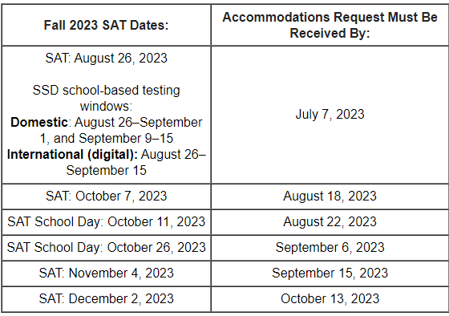

ACT Application Process: This request cannot be submitted until the student has registered for an exam.
- Student applies online (act.org) for a specific test date.
- Student and Parent complete and return the release form to allow a school official to make the accommodation request (link to form below) *include date of exam, ACT ID number and additional accommodations if requesting anything other than 50% extended time.

https://www.act.org/content/dam/act/unsecured/documents/TAA-Consent-to-Release-Information-to-ACT.pdf

- Please return forms to School Counselor, Case-Manager or Regina Hollis, SSD/TAA Coordinator Decision letters with further instructions will be forwarded to parent/student through email.
- If approved the student will be provided an accommodation PIN number that can be used for subsequent exams
- 2023-2024 dates for ACT testing below.
